1)

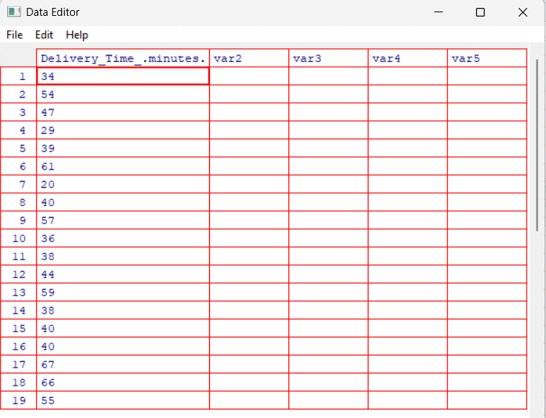



3)

4)



